“We Are IB: Going for The Gold”
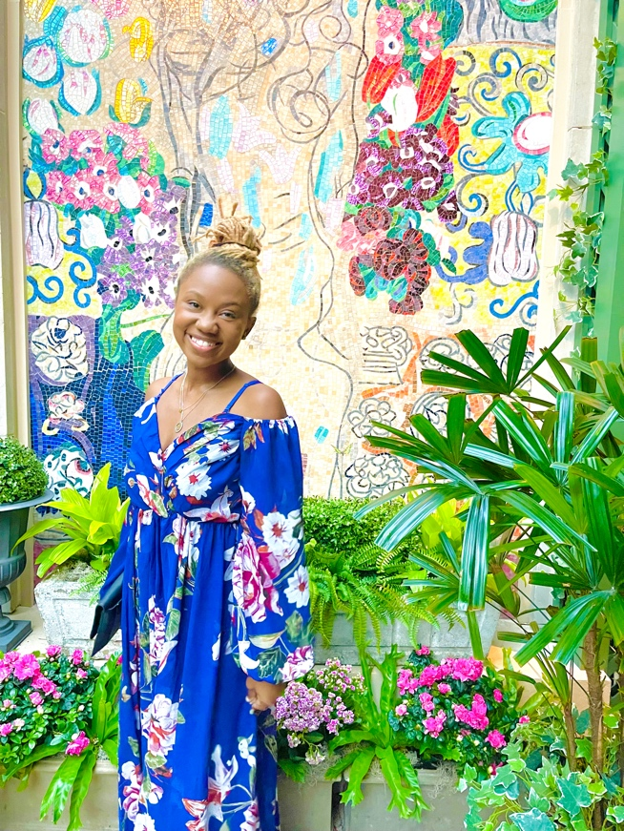 |  | Hello! I am excited to be your visual arts teacher this year! I graduated from the Unsinkable Albany State University with a degree in Art and Walden University with a Master of Science in Education. This year will be my 5th year of teaching and my 2nd year as an Art teacher. I have one son and two cats, Ivy and Jenie. I love to travel and try new food. My parents and siblings are all in education. I am delighted to teach the visual arts courses at Langford. This course will include art production, art history, and art criticism. I attended Langford Middle School as a student and I’m very excited to be a Lion again!
Class Schedule
Period | Time | Grade Level | Location
1st or 2nd | 9:20-10:40 | 8th | Art Room- 210
3rd or 4th | 12:25-1:45 | 6th | Art Room- 210
5th or 6th | 2:20-3:40 | 7th | Art Room- 210

